**How to Install PuTTY on Windows. Download & configure**

**Step 1 :** First you need to obtain a copy of the installation package (e.g., putty-<version>- installer.msi). If you have a 64-bit computer, it is recommended that you install the 64-bit version putty-64bit-<version>-installer.msi. Use this link to download.

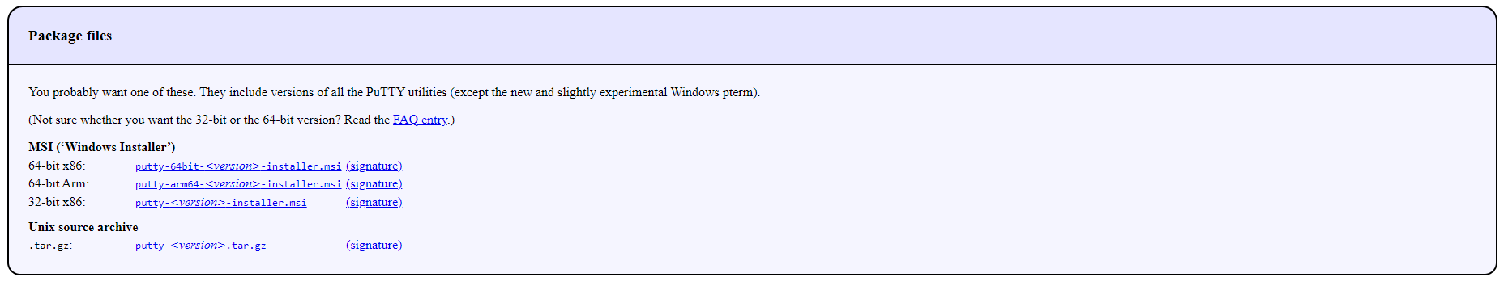

**Step 2 :** Start the installer.

On Windows 10, the Edge browser offers to run the installer when the download is complete. Just click to install the software. On older versions of Windows, you may need to run the installer manually.

Step 3 : When the installer starts, It shows the welcome screen. Just click Next.

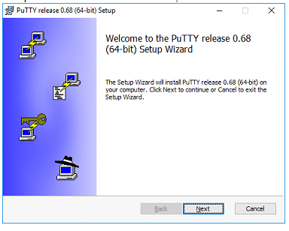

Step 4 : The installer then asks for the Destination folder in which to install the software. Almost always it is best to use the default value. Just click Next.

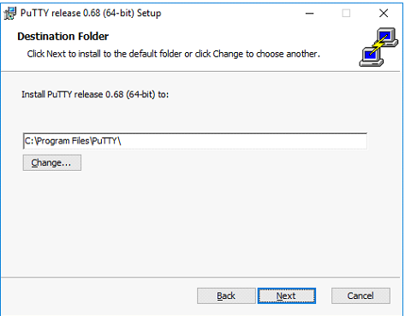

**Step 5 :** the installer asks to select product features to install. Click Install.

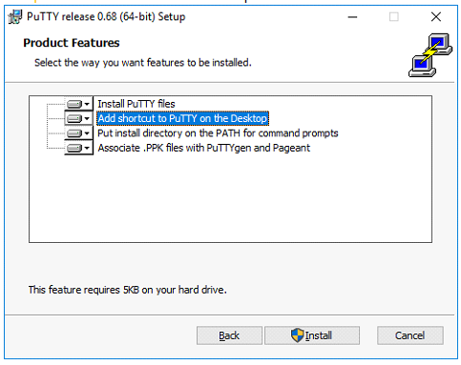

**Step 6 :** When the installation has completed successfully, it should show a "Completed" screen. Click Finish to exit the installer.

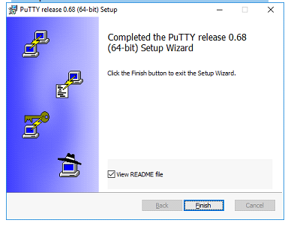

**Convert your private .pem key to .ppk using PuTTYgen**

**How to RUN Putty :**

Once installation successfully completed, you should test to make sure that PuTTY runs correctly, and you can find the program. you should be able to find the software from the Windows Start menu in the bottom left corner of the screen and start the software.

When the software starts, you should get a window with the title "PuTTY Configuration" with a field Host Name in the upper middle part. Try entering a host name to connect to in that field and click Open.